Supplementary materials
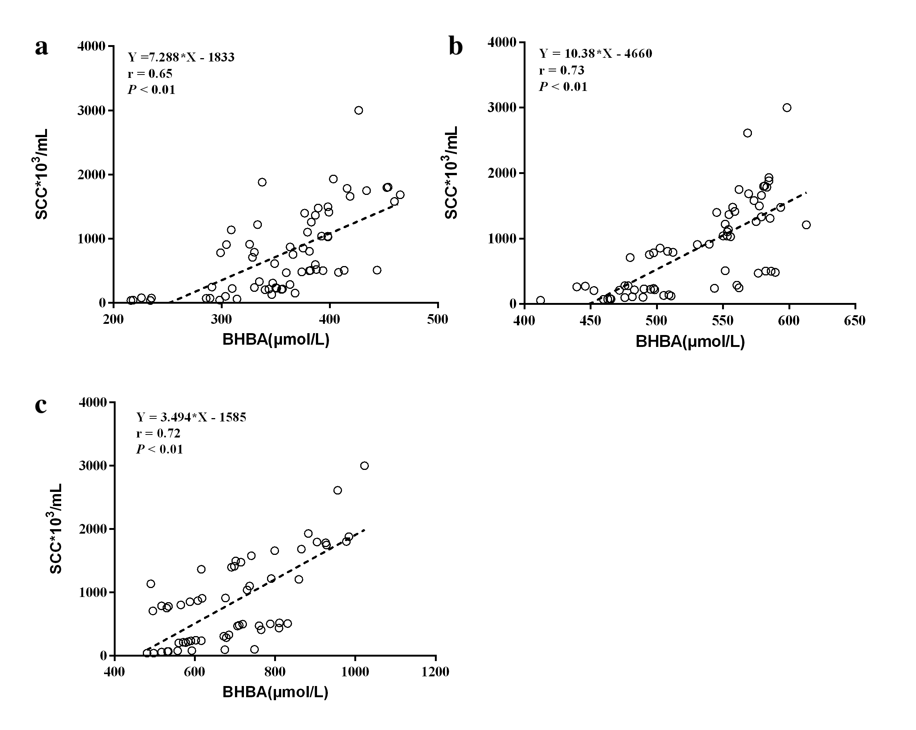
Figure S1. Correlation between β-hydroxybutyric acid (BHBA) and somatic cell count (SCC) in dairy cows at -4w (a), -3w (b), and -1w (c) relative to calving. N = 76
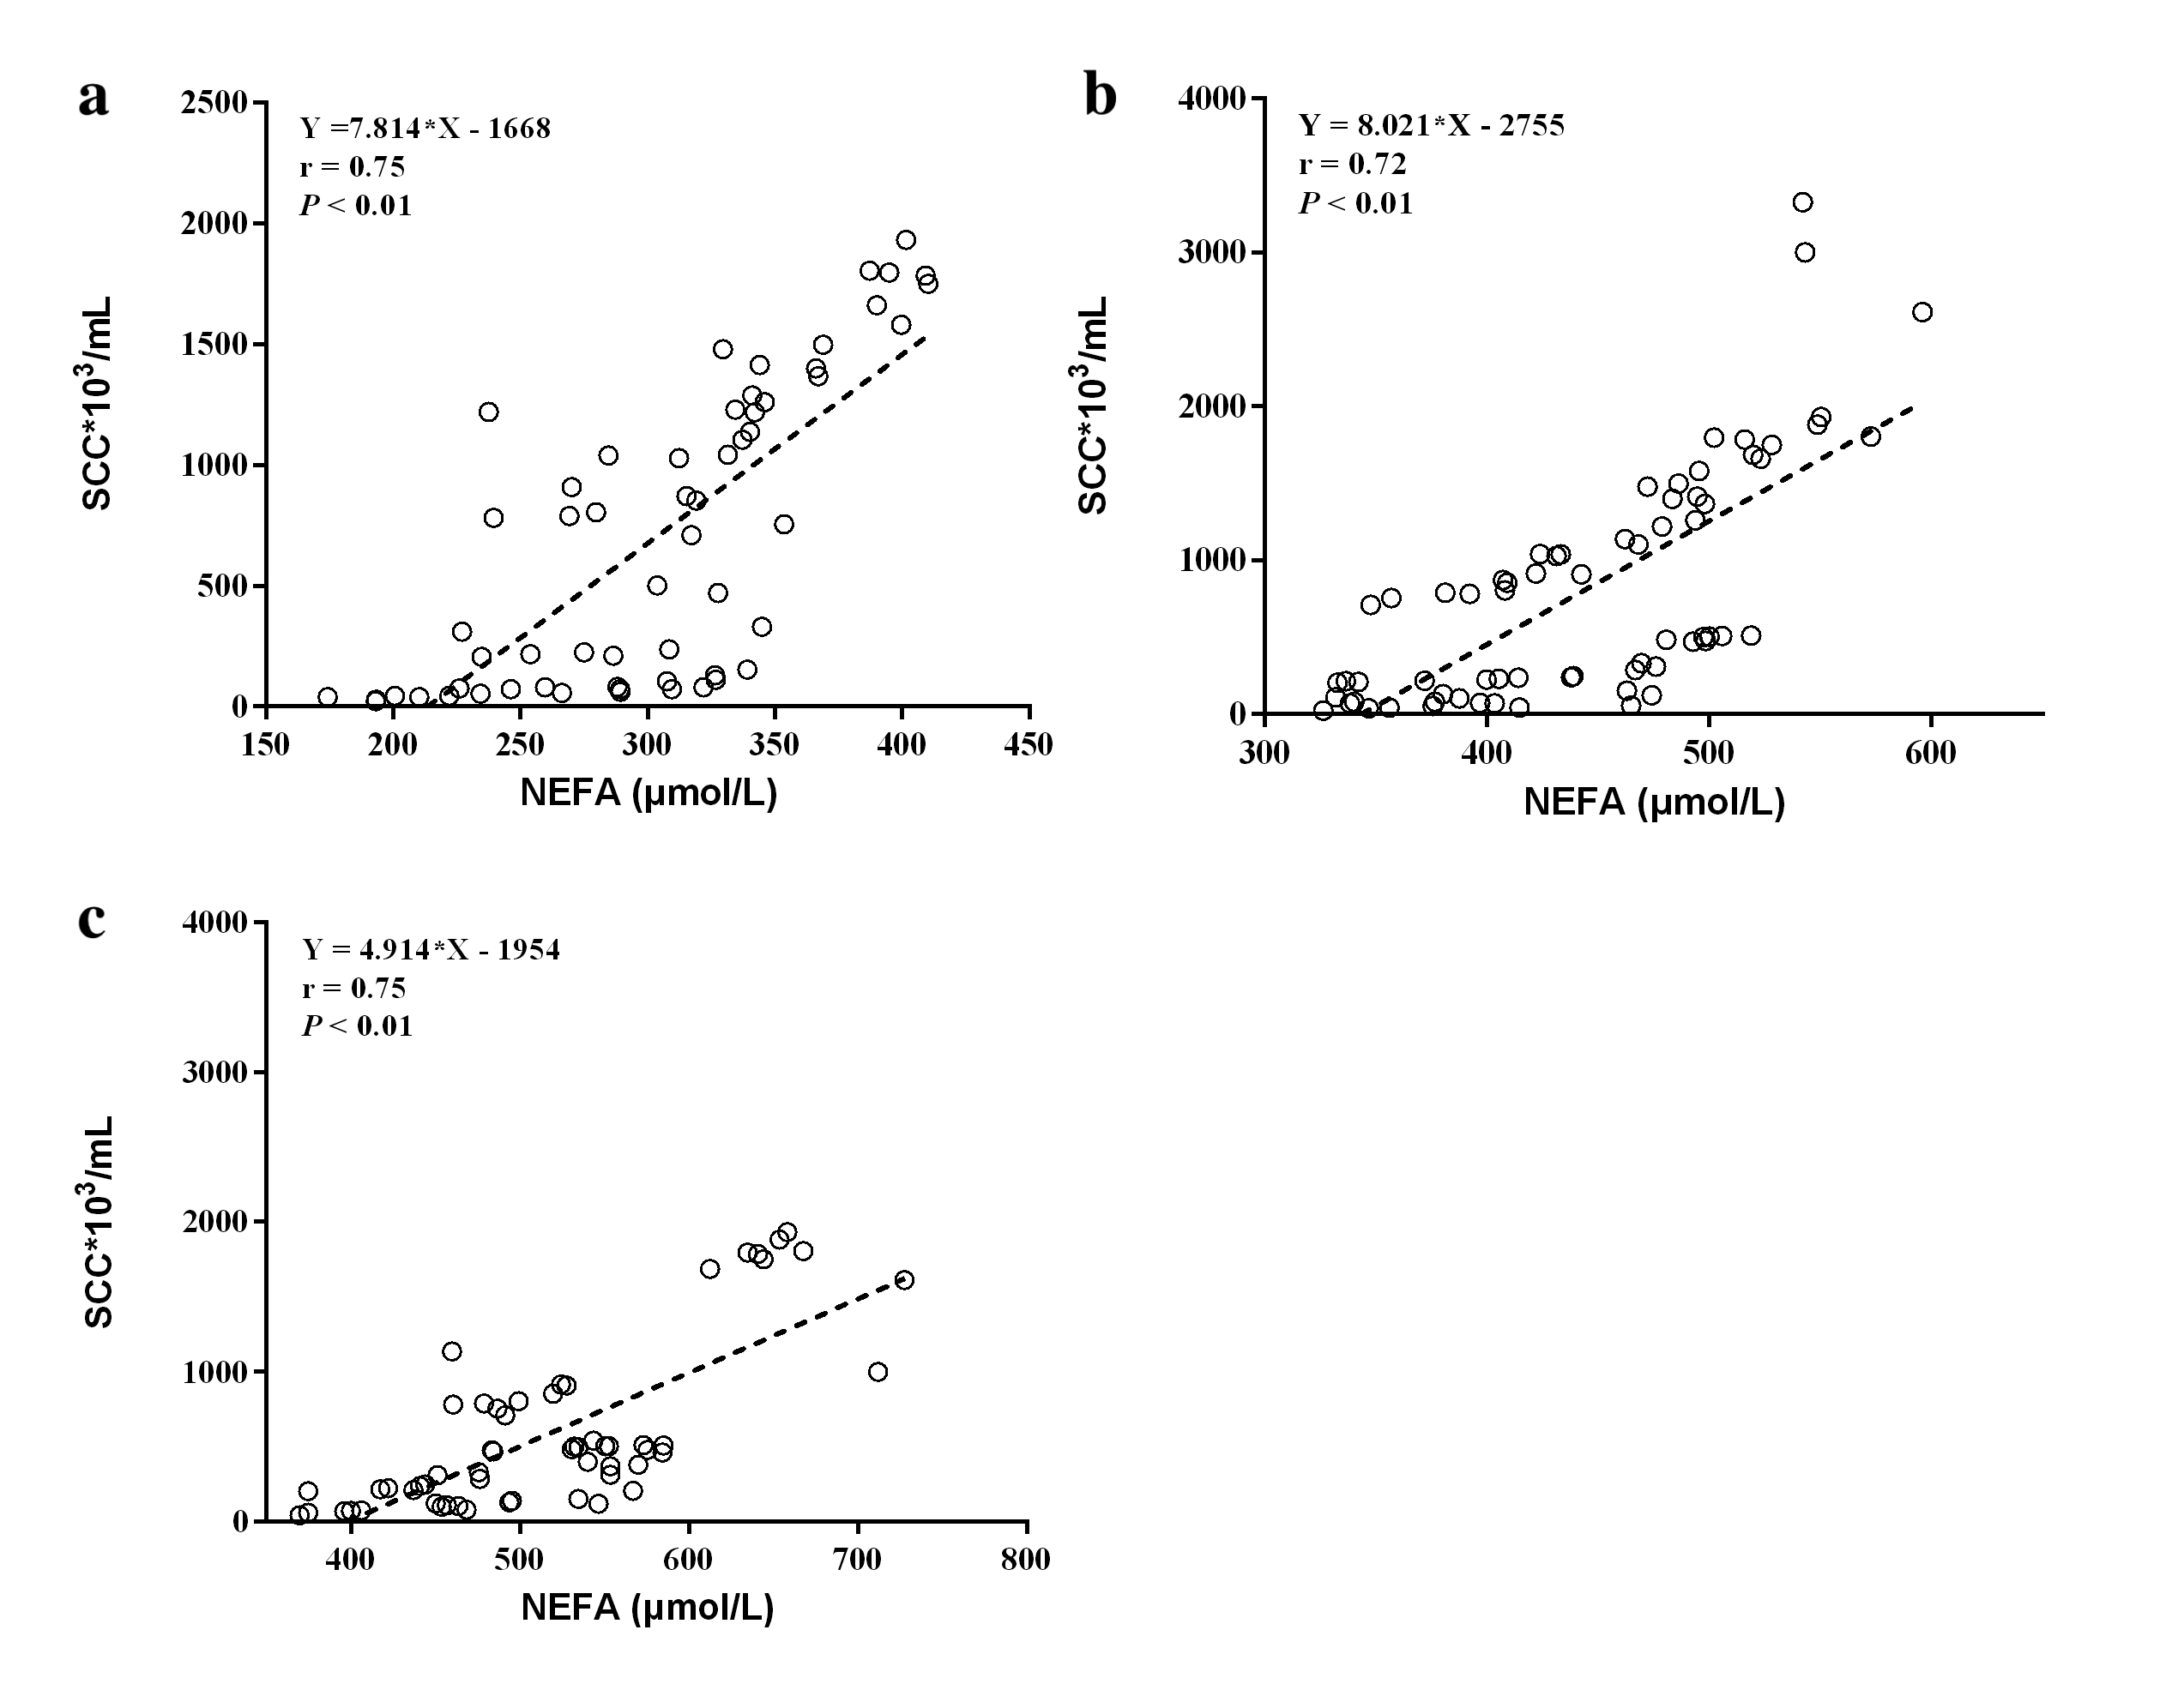
Figure S2. Correlation between non-esterified acid (NEFA) and somatic cell count (SCC) in dairy cows at -4w (a), -3w (b), and -1w (c) relative to calving. N = 76
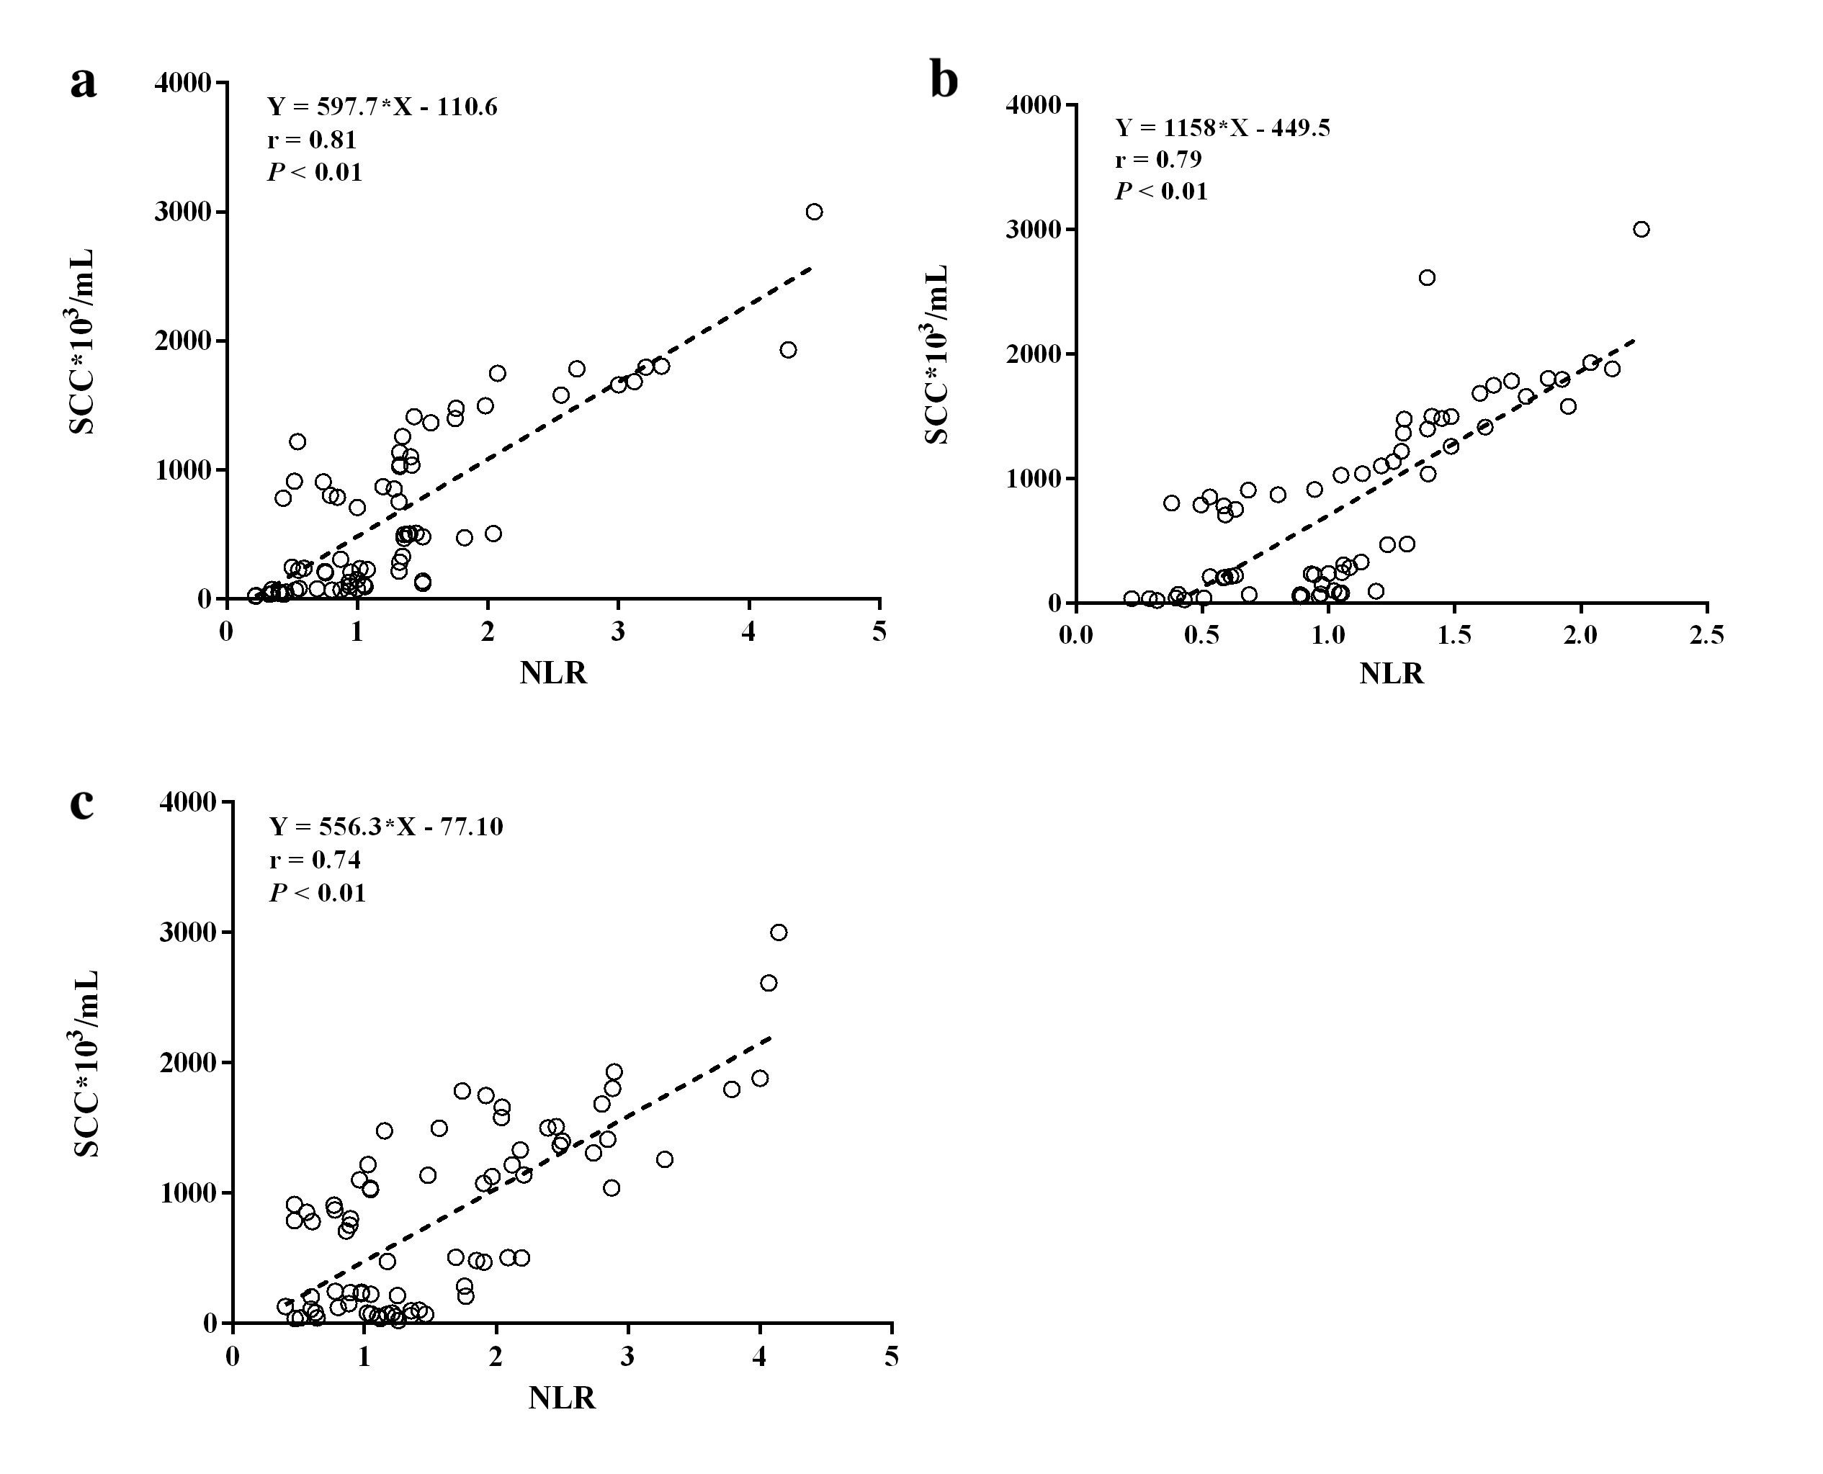
Figure S3. Correlation between neutrophil-to-lymphocyte ratio (NLR) and somatic cell count (SCC) in dairy cows at -4w (a), -3w (b), and -1w (c) relative to calving. N = 76
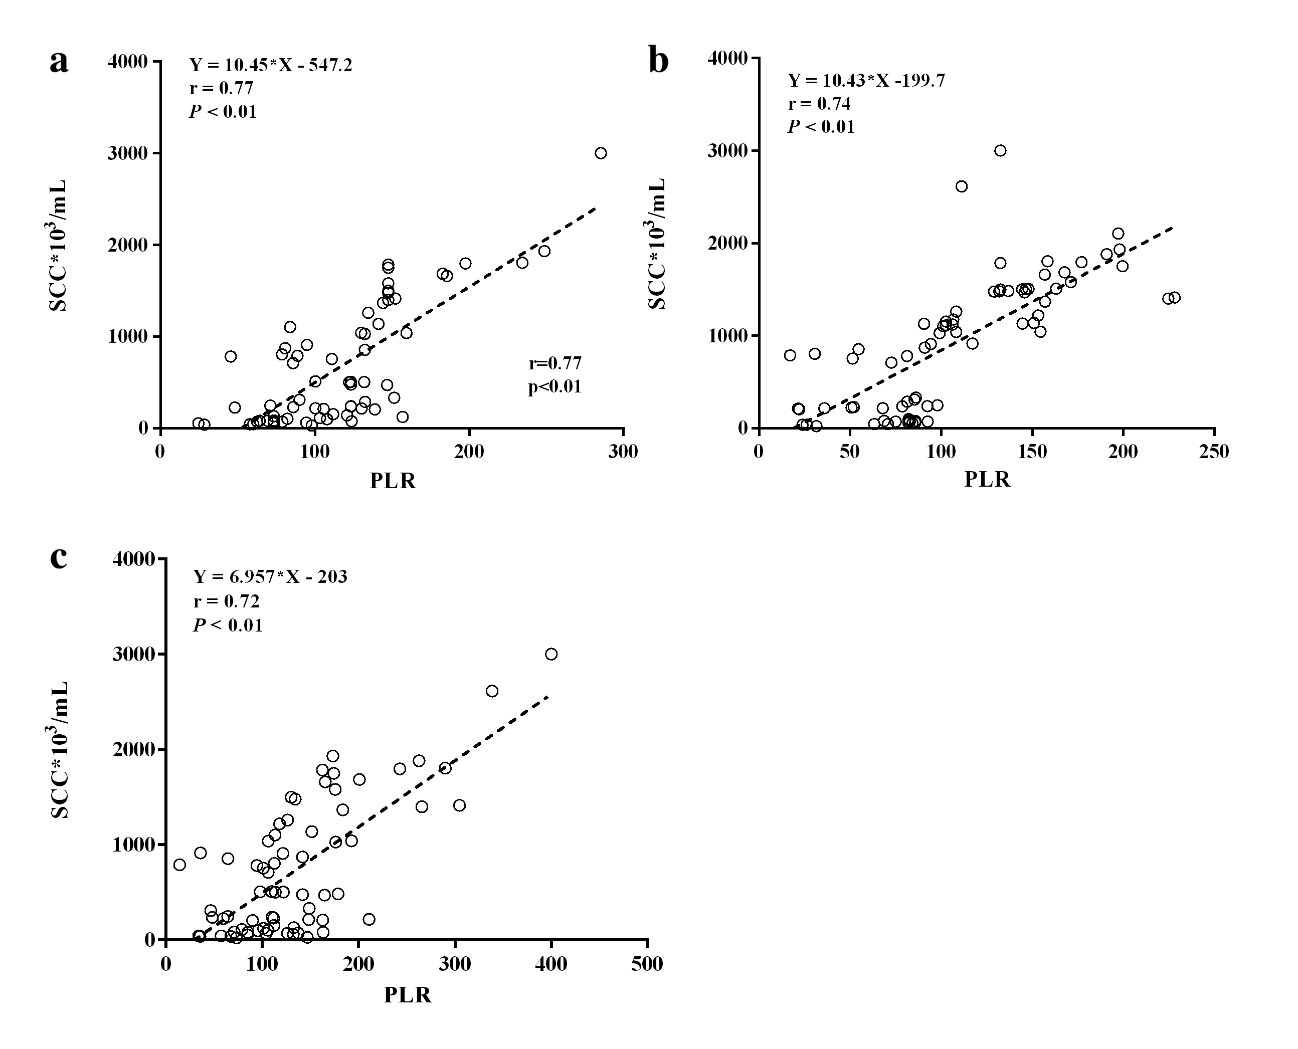
Figure S4. Correlation between platelet-to-lymphocyte ratio (PLR) and somatic cell count (SCC) in dairy cows at -4w (a), -3w (b), and -1w (c) relative to calving. N = 76
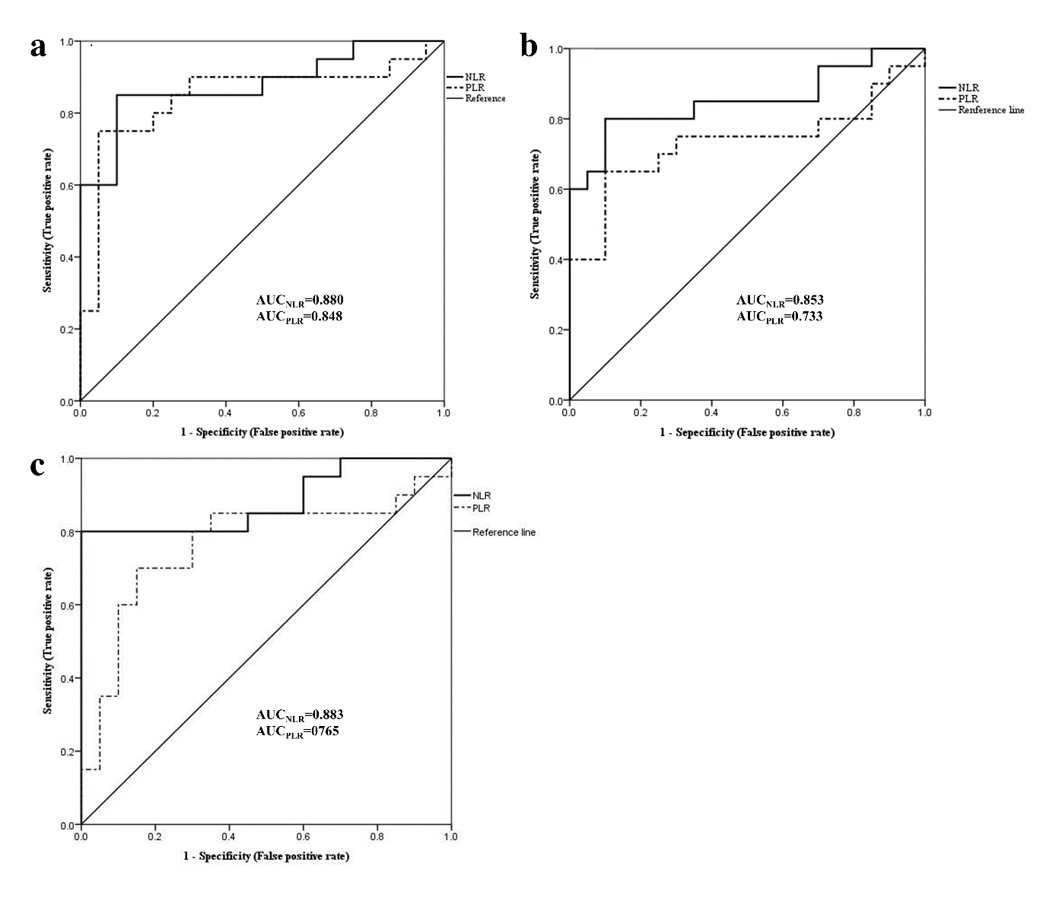
Figure S5. Receiver-operator characteristic curves of blood neutrophil-to-lymphocyte ratio (NAR) and blood platelet to-lymphocyte ratio (PLR) in dairy cows with low (LSCC) and high somatic cell count (HSCC) at -4w (a), -3w (b), and -1w (c) relative to calving. N_{(LSCC)}=23, N_{(HSCC)}=33; AUC, area under the curve
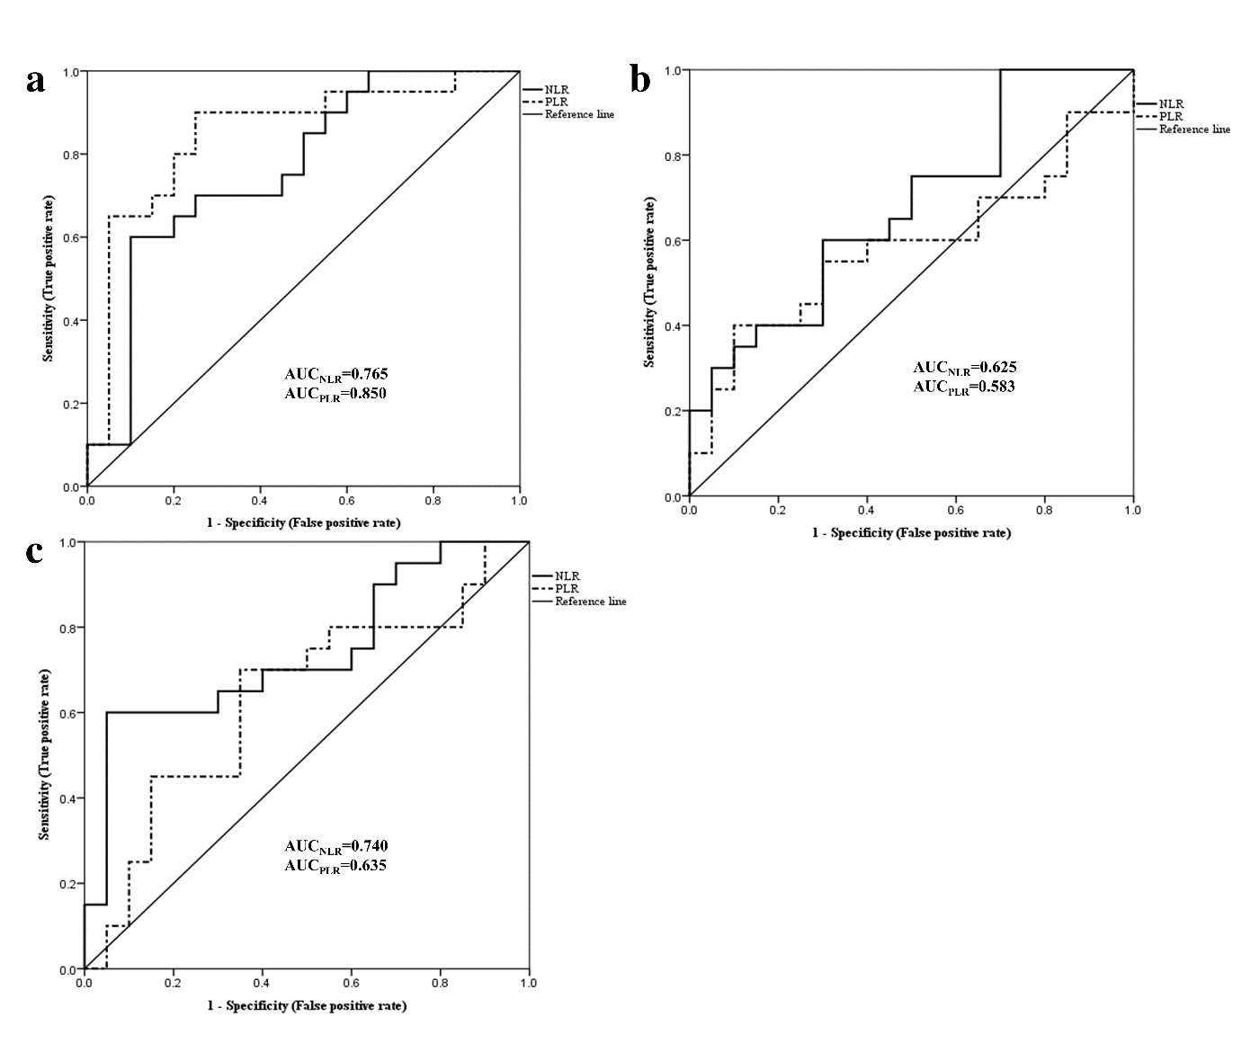Figure S6. Receiver-operator characteristic curves of blood neutrophil-to-lymphocyte ratio (NAR) and blood platelet to-lymphocyte ratio (PLR) in dairy cows with low (LSCC) and middle somatic cell count (MSCC) at -4w (a), -3w (b), and -1w (c) relative to calving. N_{(LSCC)}=23, N_{(MSCC)}=20; AUC, area under the curve.
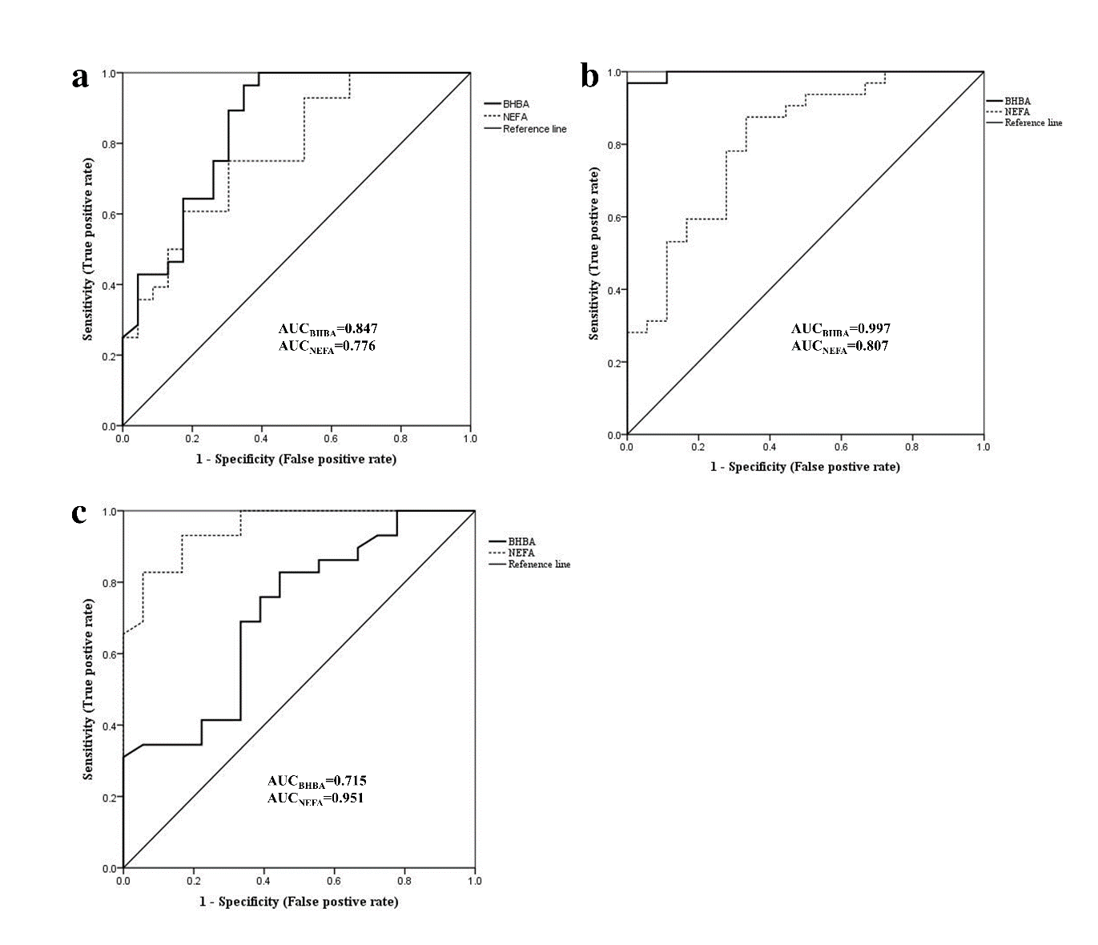
Figure S7. Receiver-operator characteristic curves of serum β-hydroxybutyrate (BHBA), non-esterified fatty acid (NEFA) in dairy cows with low (LSCC) and high somatic cell count (HSCC) at -4w (a), -3w (b), and -1w (c) relative to calving. N_{(LSCC)}=23, N_{(HSCC)}=33; AUC, area under the curve
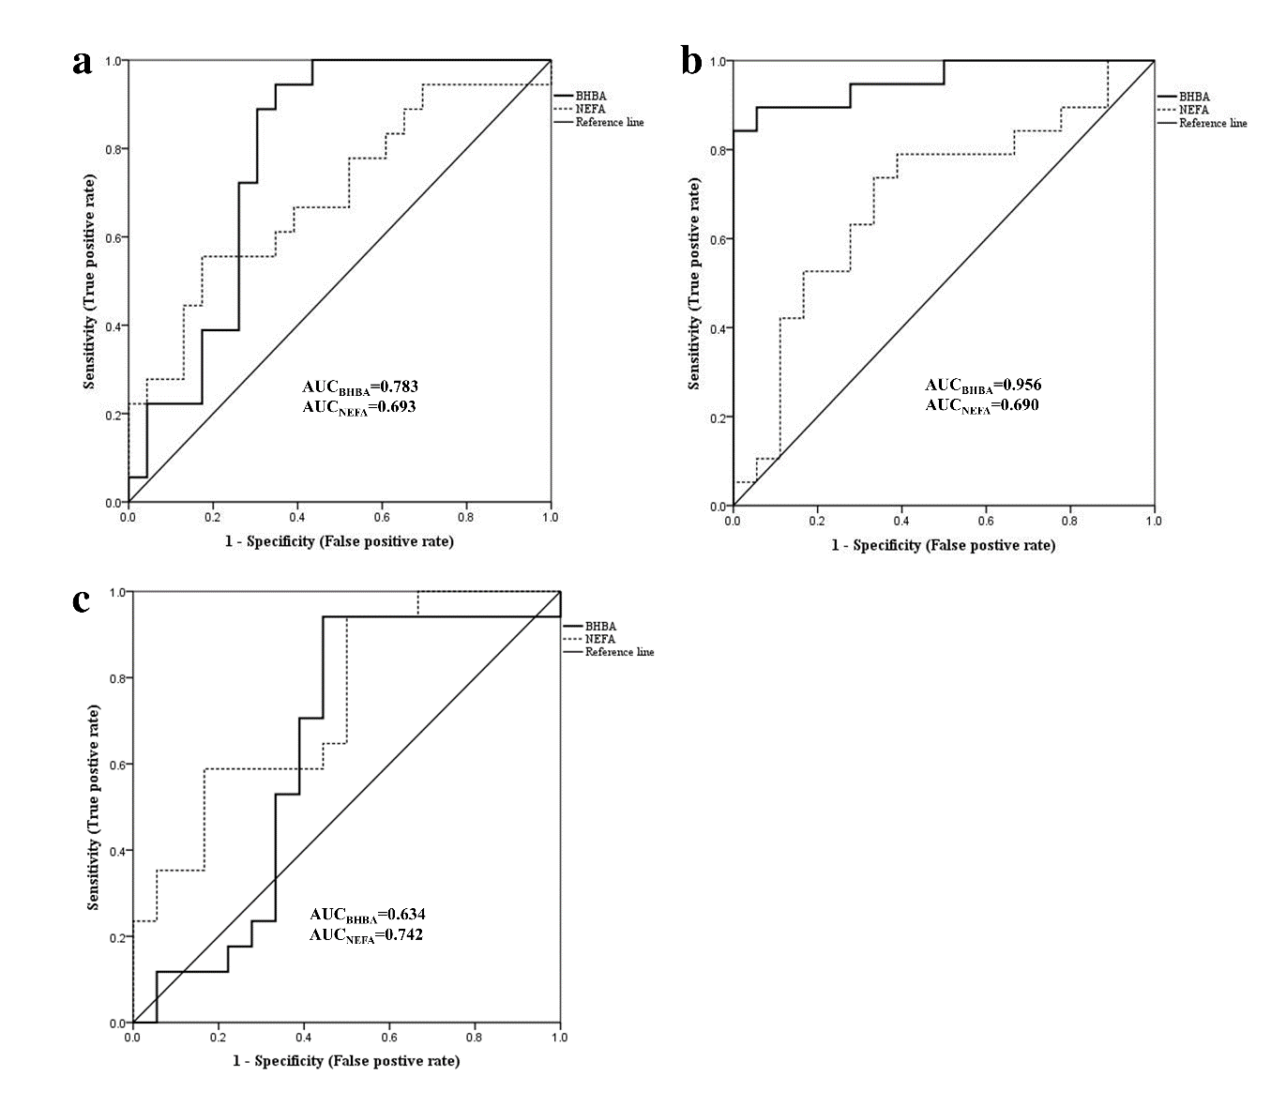
Figure S8. Receiver-operator characteristic curves of serum β-hydroxybutyrate (BHBA), non-esterified fatty acid (NEFA) in dairy cows with low (LSCC) and middle somatic cell count (MSCC) at -4w (a), -3w (b), and -1w (c) relative to calving. N_{(LSCC)}=23, N_{(MSCC)}=20; AUC, area under the curve.
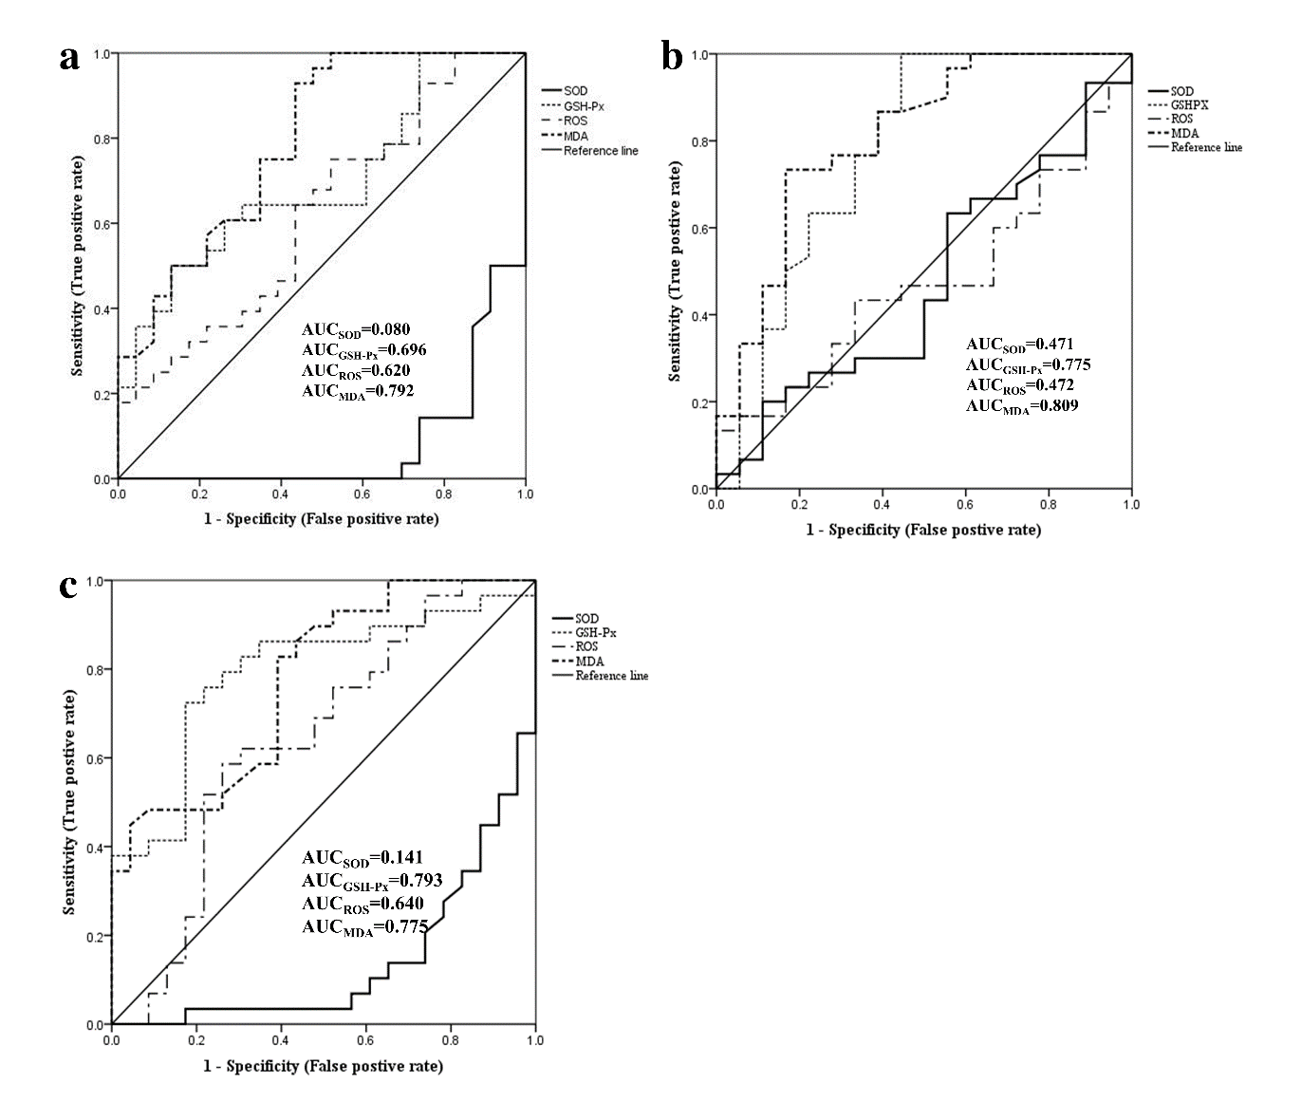
Figure S9. Receiver-operator characteristic curves of serum anti-oxidative variables in dairy cows with low (LSCC) and high somatic cell count (HSCC) at -4w (a), -3w (b), and -1w (c) relative to calving. N_{(LSCC)}=23, N_{(HSCC)}=33; AUC, area under the curve; GSH-Px, glutathione peroxidase; MDA, malondialdehyde; ROS, reactive oxygen species (ROS); SOD, serum superoxide dismutase.
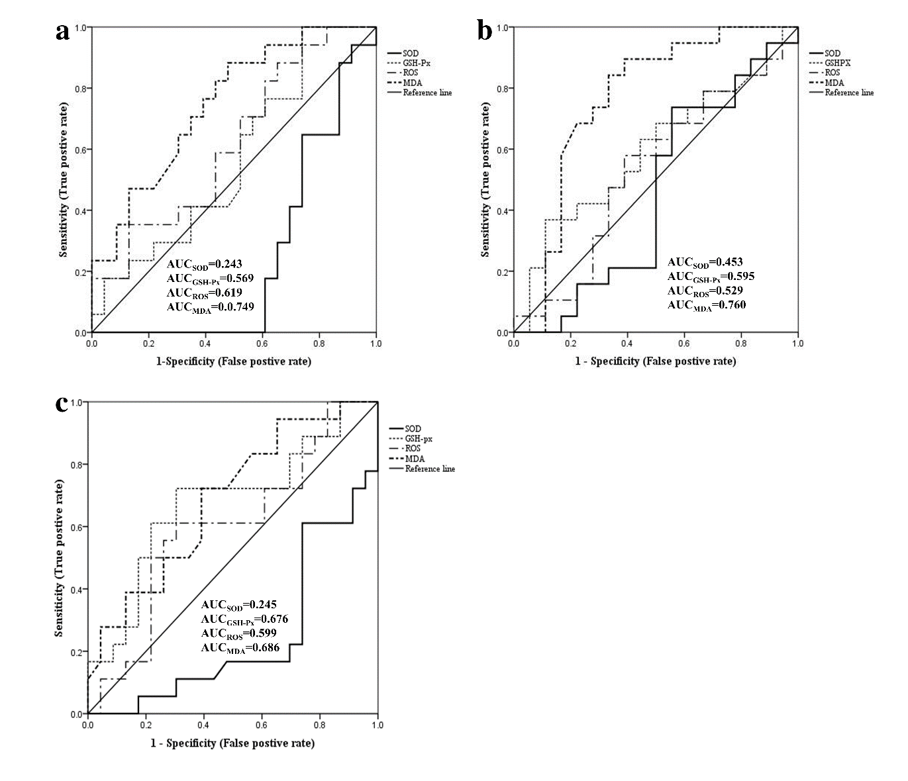
Figure S10. Receiver-operator characteristic curves of serum anti-oxidative variables in dairy cows with low (LSCC) and middle somatic cell count (MSCC) at -4w (a), -3w (b), and -1w (c) relative to calving. N_{(LSCC)}=23, N_{(MSCC)}=20; AUC, area under the curve; GSH-Px, glutathione peroxidase; MDA, malondialdehyde; ROS, reactive oxygen species (ROS); SOD, serum superoxide dismutase.

